
H A D P

Monthly Progress Report- June

HADP- Project – 10

Promotion of Year Round Mushroom Production

Activity/Code | Achievement  2025-26
Activity/Code | Phy. | Fin. (Crore)
- Evaluation of High value Mushroom strains  - Evaluation of apple pruned wood based substrate for cultivation High value mushroom cultivation | Shiitake, Enokeii, King oyster, Ganoderma, Shimiji and Elm oyster  Evaluation of apple pruned wood based substrates for cultivation of Shiitake, Enokeii, King oyster, Ganoderma, Shimiji and Elm oyster Mushrooms | Approved | Released | Expenditure
 |  | 0.20 | 0.10 | 0.00

Prof Shaheen Kouser Jan
(Principal Investigator)

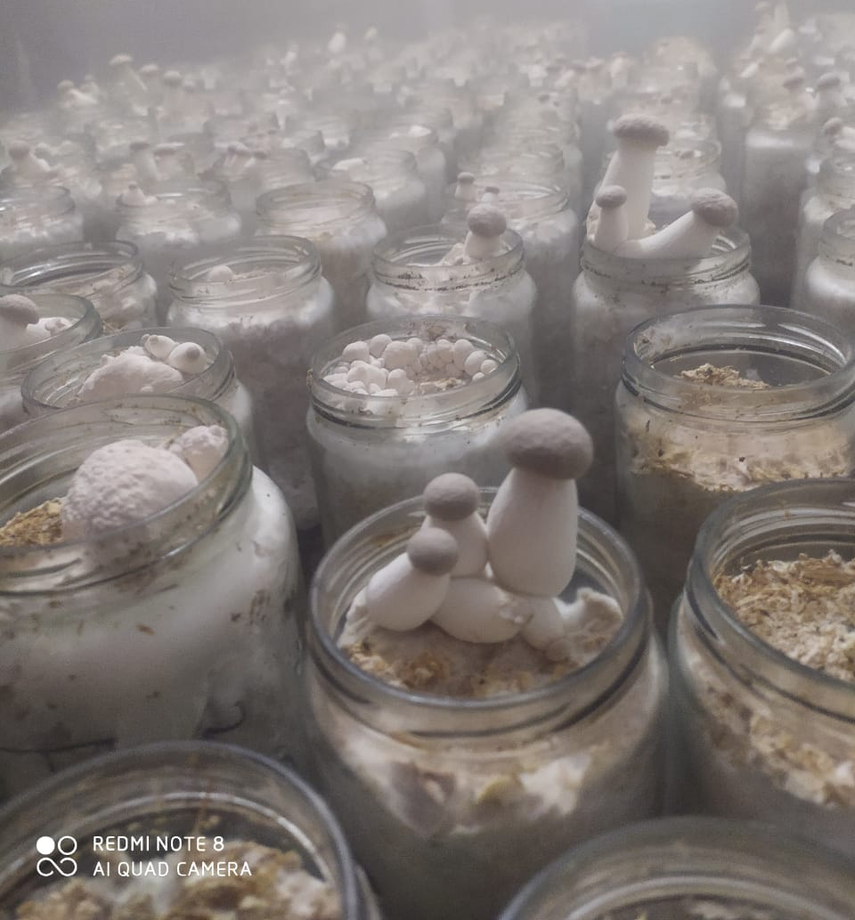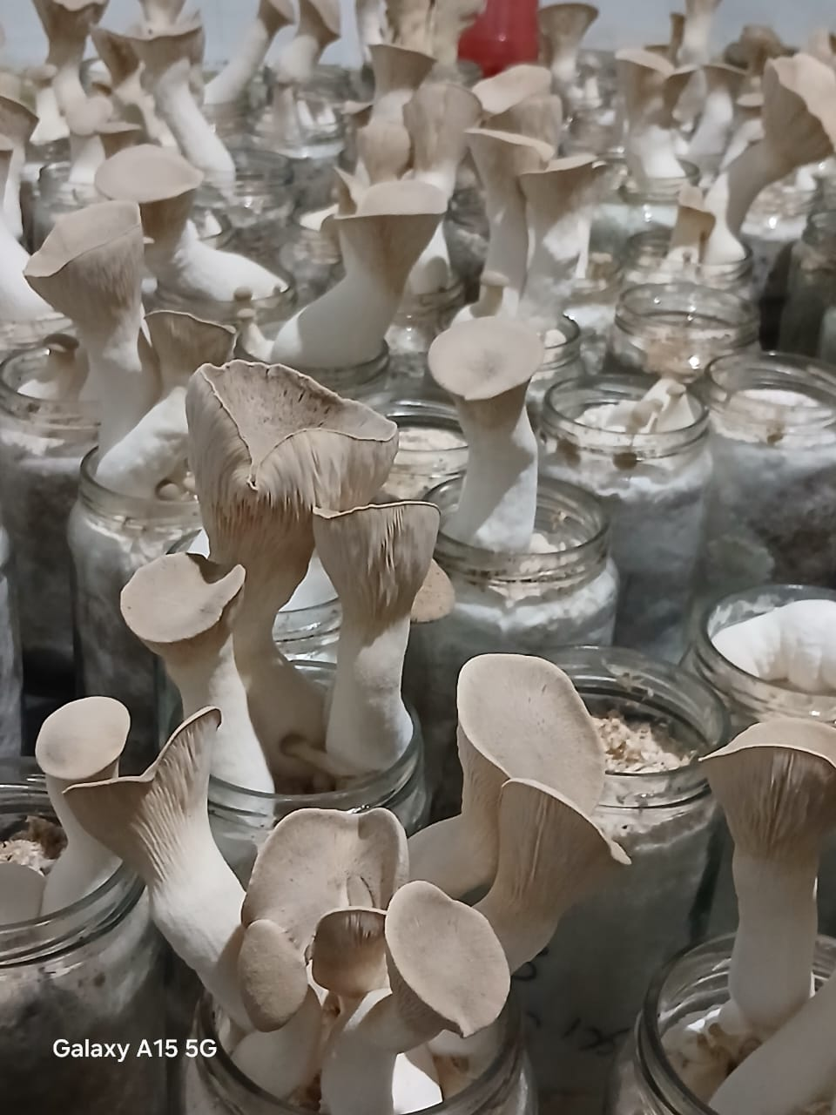
King Oyster Mushroom Cultivation

